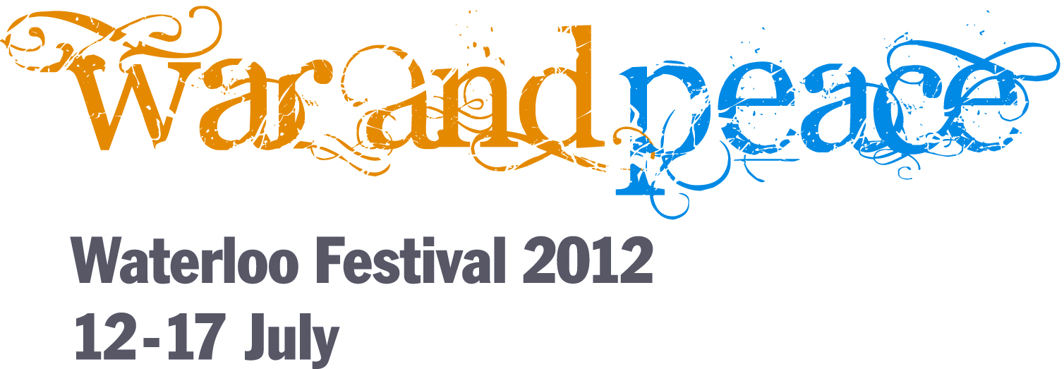

DISCUSSION

Is Peace Possible in a World of Diminishing Resources?

Monday 16 July - 6 pm
St John’s Church, Waterloo Road, London SE1 8TY

Loretta Minghella - Chief Executive, Christian Aid (Chair)

Tom Coghlan - Defence Correspondent for The Times

Rev Rana Khan - The Archbishop of Canterbury's Interreligious Dialogues Assistant

Oliver Ramsbotham – former Professor of Peace Studies at Bradford University

The Waterloo Festival returns for its second year, this time with the theme of ‘War and Peace’. The biggest challenge for peace in the 21st century is competition for resources: land, water, fossil fuels. The panel will discuss whether a peaceful world is possible, and if so, how?


Tickets: £5

Book online www.stjohnswaterloo.org/waterloofestival
Or by phone 020 7633 9819
Or in person at St John’s Waterloo, SE1 8TY

